School of Social Sciences

Economics

C29PE

Economics for professionals

SOLUTIONS

December Examination and Assessment Diet 2024-2025

Duration: 2 Hours

Section A: Multiple Choice Questions

There are 20 questions in this section. Please answer all questions at the start of your answer paper. Each question is worth 1.5 marks.

Answer key:

1 | a | 6 | d | 11 | D | 16 | b
2 | b | 7 | c | 12 | d | 17 | B
3 | b | 8 | c | 13 | C | 18 | d
4 | d | 9 | b | 14 | c | 19 | B
5 | C | 10 | a | 15 | a | 20 | c

Question 1
Recent postings by social media influencers have spurred a craze for exercise bikes. However, a recent shortage of global shipping capacity has interrupted market supply. We predict the following outcomes in the market
A. Increasing demand and falling supply causing prices to rise
B. Falling demand and increasing supply causing prices to rise
C. Increasing demand and falling supply causing falling prices
D. Falling demand and supply causing rising in prices
Answer: A

Question 2
During a ten year career as a lawyer, Amy estimates that she has spent more than $100,000 on education and training opportunities. She is now thinking of retraining to become a professional photographer. In making her choice, Amy should consider:
A. The investments which she has already make in becoming a lawyer
B. The benefits from the career change, and the costs of making it
C. The sunk cost of becoming a lawyer and the costs of making the career change
D. The opportunity cost of becoming a photographer and the value of her investment in becoming a lawyer
Answer: B

Question 3
Consolidation within the accountancy profession has reduced competition for audit work, enabling firms to increase the fees which they charge. Regulators are considering introducing a price ceiling to prevent overcharging. Which one of the following statements will not apply if the policy is effective.
A. There will be a reduction in the fees which clients pay
B. The supply of audit services will increase
C. There will be unmet demand for audit services
D. Accountancy firms’ mark up on costs will decrease
Answer: B

Question 4
To increase the number of students for its online MBA programme, Edinburgh Business School reduces the price which it charges for each course from £1,500 to £1,000. It was observed that the student numbers in the current intake increased from 300 to 700. Using the mid-point formula, we can conclude that
A. Demand is price inelastic, with elasticity approximately equal to -0.5
B. Demand is price elastic, with elasticity approximately equal to -4
C. Demand is price inelastic, with elasticity approximately equal to 0.5
D. Demand is price elastic, with elasticity approximately equal to -2.
Answer: D

Question 5
A market research firm recently published a report on the purchase of mobile phones in Malaysia. Brand conscious tended to choose between iPhone or Huawei devices. We therefore expect to observe a cross-price elasticity of demand for iPhones and Huawei which is
A. Less than zero
B. Zero
C. Greater than zero
D. One
Answer: C

Question 6
When an increase in output is associated with an increase in marginal cost, which of the following might we be certain to find?
A. An increasing marginal physical product of labour
B. An increase in the firm’s total fixed costs
C. Decreasing average variable costs
D. Diminishing marginal product of labour
Answer: D

Question 7
Three of the following are examples of economies of scale. Which one is not?
A. A business benefits from discounts from ordering supplies of intermediate inputs in very large quantities
B. A business has agreed contracts with substantial buyers of its output, securing future revenues, and reducing the costs of raising finance
C. A business has many layers of management, which make decisions very slowly by following standard procedures
D. A business is able to find many opportunities for the division of labour and specialisation of roles, increasing the productivity of its employees
Answer: C

Question 8
In a monopolistically competitive market, if market demand increases, then we expect to observe
A. The exit of firms from the market and a reduction in competition
B. A reduction in the market price, but an increase in marginal revenues
C. An Increase in both average and marginal revenues
D. The elimination of economic profits in the short run
Answer: C

Question 9
Firms selling their output in a perfectly competitive marking are facing losses in the short run. We can expect the following to occur
A. Any firm which is unable to cover its short-run total costs of production will leave the market
B. Some firms will leave the market in the long run, allowing the remaining firms to make normal profits
C. In the long run, more firms will enter the market, increasing demand and ensuring that the market price falls
D. Any firm which is unable to cover its short-run fixed costs will shut down production
Answer: B

Question 10
Which of the following is the best example of a public good?
A. The illumination produced by streetlights
B. A coach service between the two largest cities in the country
C. Public roads on which anyone can drive
D. A golf course owned by the members of a club
Answer: A

Question 11
If one quarter of income is used for taxation, ten per cent of income is saved, and ten per cent of income is used to purchase goods and services produced abroad, the marginal propensity to spend on domestic goods is:
a) 0.45
b) 0.25
c) 0.5
d) 0.55
Answer: D

Question 12
Here is a simple model of a closed economy
Consumption: C = 600 + 0.5Yd
Disposable income: Yd = Y - T
Investment: I = 2,000
Government spending: G = 2,400
Tax: T = 0.2Y
The equilibrium income of the economy is
A. 12,500
B. 7,500
C. 10,000
D. 8,333
Answer: D

Question 13
You are given the following information about a closed economy in equilibrium. Saving (S) = 4,200, and the government budget deficit (G – T) = 200. What is the value of investment expenditure?
A. I = 2,200
B. I = 4,200
C. I = 4,000
D. I = 4,400
Answer: C

Question 14
According to the Quantity Theory of Money, the value of payments in money in a year equals nominal GDP. It follows that in a country with a monetary stock M = 3,000, a price level P = 1.25, and real GDP, Y = 2,000, the velocity of circulation (V) is
A. 0.625
B. 0.667
C. 0.833
D. 1.75
Answer: C

Question 15
Given that the liquidity ratio of the banking system is 20%, if businesses deposit an additional $250m, then we expect that a further
A. $1,000m worth of new deposits will be created
B. $300m worth of new deposits will be created
C. $250m worth of new deposits will be created
D. $50m worth of new deposits will be created
Answer: A

Question 16
Suppose that the economy experiences a negative supply shock due to a sudden increase in the costs of energy imports. Such a shock raises the costs of production and causes inflationary pressures. If the central bank responds by tightening monetary policy to reduce inflationary pressures, we can be certain that the combination of shock and policy response will lead to
A. A reduction in the price level (but national income may increase)
B. Control of inflation, but with lower national income
C. A higher price level (and national income may decrease)
D. An increase in both the price level and national income
Answer: B

Question 17
The economy is presently in a long-run equilibrium, with expected inflation equal to actual inflation. A sudden fall in aggregate demand causes a temporary fall in the inflation rate and an increase in the unemployment rate. If there is no response from the government, we can predict that in the long run,
A. Expected inflation rate will rise, and the economy returns to full employment
B. Expected inflation rate will fall, and the economy returns to full employment
C. Expected inflation rate will remain unchanged, and the economy returns to full employment
D. Expected inflation rate will fall, but the economy remains below full employment
Answer: B

Question 18
A recession brought about by a loss of international competitiveness will be associated with an increase in which form of unemployment in the short run?
A. Frictional unemployment
B. Structural unemployment
C. Real wage unemployment
D. Cyclical unemployment
Answer: D

Question 19
Which of the following constitutes a market-oriented supply-side policy?
A. Government increases support for in-work training schemes
B. Government increases tax reliefs for capital investment
C. Government industrial policy includes holding equity stakes in strategic businesses
D. Government increases investment in strategic infrastructure, including railways and ports
Answer: B

20. Suppose that there are only 2 countries in the world, namely Asiana and Europa. Each country produces only two goods – rice and tomatoes. Asiana employs 500,000 workers, while Europa has 250,000 workers. The table below shows the production of each good using one worker:

 | Country
Goods | Asiana | Europa
Rice (tonnes) | 2 | 3
Tomatoes (tonnes) | 5 | 6

Which statement below is true?
A. Europa has a comparative advantage in both goods
B. Asiana has a comparative advantage in production of rice and Europa has a comparative advantage in production of tomatoes
C. Europa has a comparative advantage in production of rice and Asiana has a comparative advantage in production of tomatoes
D. Both Europa and Asiana have absolute advantages in the production of one good
Answer: C

(30 marks)

Section B: Short Answer Questions

There are four questions in this section, each worth 10 marks. You should answer all four

Question 1

From time to time, the Scottish national football team qualifies for the finals of a major tournament and proceeds to disappoint its fans by returning home early. However, those fans generate huge opportunities for retailers. Suppose that a seller of replica strips has purchased a stock of 500 shirts from the manufacturer, clearly marked as special editions. They cost £10 each but can be sold for £50 before the tournament. There is a risk that the retailer will be left with unsold stock, which the manufacturer will purchase for £1 (to recycle them).
- Explain the concept of opportunity cost and state the opportunity cost for the retailer of purchasing the replica shirts before purchase. (2 marks)
Answer: Opportunity cost is the value of the next best alternative forgone. In this case, the retailer could have purchased goods with a wholesale value of £5,000

- After the retailer has bought the T-shirts from the manufacturer, apply the concept of opportunity cost to the retailer’s intention to sell the shirts to Scotland supporters. (2 marks)
Answer: The retailer has the option of selling the T-shirts back to the manufacturer who made them, but at the substantially discounted price of £1. The opportunity cost of each lost sale is £49.

- Suppose that the Scottish football team loses its first game heavily but is still in the competition. The retailer still has over 200 shirts on sale for £50 per piece. A store manager suggests cutting the price to £25 and selling these T-shirts quickly, but firm’s marketing manager objects that this means losing £25 per shirt. Discuss whether it is worthwhile accepting that loss. (2 marks)
Answer: The purchase cost of the unsold shirts is a sunk cost to the retailer and hence it should not influence current decision-making. The retailer only has 2 options to consider, either to sell the T-shirts at £25 per piece, or sell the T-shirts back to the manufacturer at £1 each. Receiving £25 per shirt is clearly a superior outcome.

- Explain how the opportunity cost principle gives rise to the prediction that a business in perfect competition will tend to make zero economic profits in the long run. (4 marks)

Answer: Economic costing is based on opportunity cost. The resources which the firm owns, represented by its capital, could be put to other uses. Its opportunity cost is therefore the market interest rate. If the firm generates greater returns than the market rate, it makes economic profits and should expand, so is not in a long-run equilibrium; similarly, an economic loss should lead to reduction in the firm’s activities.
(10 marks)

Question 2

In the market for luxury greetings cards, a small producer can hire up to 10 staff, paying a wage of 12.00 per hour, with a fixed cost of 40.00 attributable per hour of work. It can sell its cards at a price of 2.50.

Workers | 1 |  | 2 |  | 3 |  | 4 |  | 5 |  | 6 |  | 7 |  | 8 |  | 9 |  | 10
Production per Hour Worked | 3 |  | 8 |  | 15 |  | 24 |  | 32 |  | 39 |  | 45 |  | 50 |  | 54 |  | 56
TVC
TFC
AVC
AFC
AC
MC
In the table, the abbreviations in the row headings represent:
TVC: total variable cost; TFC: total fixed cost; AVC: average variable cost
AFC: average fixed cost; AC: average cost; MC: marginal cost

- Complete the table. (Reproduce the table in your answer booklet and fill up the blanks.) (5 marks)

- Sketch the MC, AVC and AC curves. (You may use the graph paper included in the answer booklet) (3 marks)

- If the card company has monopoly power, explain how it intends to maximise profits. (2 marks)

(10 marks)
Answer:
(a)
Workers | 1 |  | 2 |  | 3 |  | 4 |  | 5 |  | 6 |  | 7 |  | 8 |  | 9 |  | 10
Production | 3 |  | 8 |  | 15 |  | 24 |  | 32 |  | 39 |  | 45 |  | 50 |  | 54 |  | 56
TVC | 12 |  | 24 |  | 36 |  | 48 |  | 60 |  | 72 |  | 84 |  | 96 |  | 108 |  | 120
TFC | 40 |  | 40 |  | 40 |  | 40 |  | 40 |  | 40 |  | 40 |  | 40 |  | 40 |  | 40
AVC | 4 |  | 3 |  | 2.4 |  | 2 |  | 1.88 |  | 1.85 |  | 1.87 |  | 1.92 |  | 2 |  | 2.14
AFC | 13.33 |  | 5 |  | 2.67 |  | 1.67 |  | 1.25 |  | 1.03 |  | 0.89 |  | 0.8 |  | 0.74 |  | 0.71
AC | 17.33 |  | 8 |  | 5.07 |  | 3.67 |  | 3.13 |  | 2.87 |  | 2.76 |  | 2.72 |  | 2.74 |  | 2.86
MC |  | 2.4 |  | 1.71 |  | 1.33 |  | 1.5 |  | 1.71 |  | 2 |  | 2.4 |  | 3 |  | 6

(b)
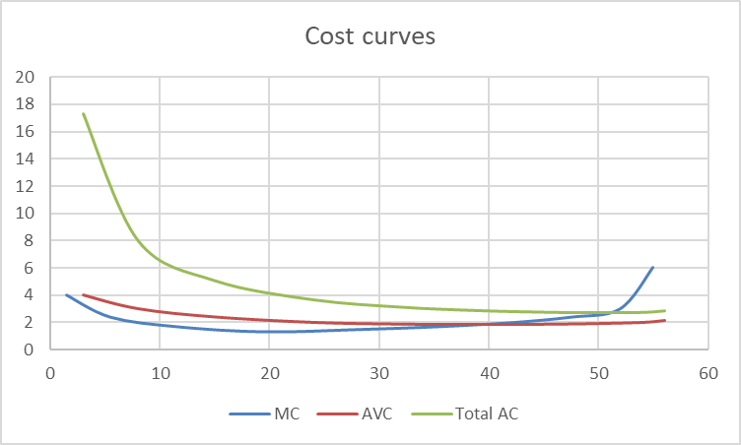
(c) Since the card company can sell any number of cards at a price of 2.50, its marginal revenue is also 2.50. It should hire 8 workers, since on hiring a ninth worker, the marginal cost of producing a card will be greater than the marginal revenue from selling it.

Question 3

You are given the following information, relevant for determination of the national income of Parthia:
Domestic consumption C = 0.75Y^{D}
Disposable income Y^{D} = Y – T
Taxation T = 0.2Y
Imports M = 0.15Y
Injections J = I + G + X = 5,500
(Y: national income;
I: investment expenditure; G: government expenditure; X: exports)

- Calculate the equilibrium national income of Parthia. (4 marks)

National income Y = C + J – M = 0.6Y + 5,500 – 0.15Y = 5,500 + 0.45Y
So, Y = 10,000.

- Explain what would happen to national income if exports were to increase by 220. (2 marks)
From (a), 0.55DY = 220, so DY = 400.

c) Briefly explain why the predictions of this model about the effects of investment on the economy might be different from the predictions of an aggregate supply – aggregate demand approach. (4 marks)
Students should write about the impact of investment expenditure on the productive capacity of the economy, characterising increased investment as first shifting the aggregate demand curve to the right, followed by the aggregate supply curve. Students should note that this means that we can be certain the effect of investment will be an increase in national income, but that we cannot be certain about the effect on the price level in the economy.
(10 marks)

Question 4

The following displays items in the 2023 balance of payments ($ billions) for Boland, a small developing economy.

Export of goods | 180
Export of services | 150
Direct and portfolio net investment in Boland from abroad | 30
Income receipts on investment | 20
Import of goods | 120
Import of services | 160
Direct and portfolio investment abroad | 110
Income payments made on investment | 65
Capital transfers to Boland from abroad | 10
Capital transfers abroad from Boland | 5
Reserves (draw down) | 65

(a) Compute the current account balance. (2 marks)
Exports + income receipts less (imports and income payments)
180 + 150 +20 – 120 – 160 – 65 = 5 (surplus)

(b) Calculate the capital account and financial account balance. (2 marks)
Capital account: net capital transfers into Boland
10 – 5 = 5 (surplus)
Financial account: Net portfolio investment by Boland + draw down of reserves
(30 – 110) + 65= -5 (deficit)

(c) What is magnitude of the net errors and omissions? (1 mark)
Overall balance = -5; so net errors and omission = 5
(d) What should we conclude about the currency regime which Boland operates?
(3 marks)
Since Boland is drawing on official reserves, we conclude that it is intervening in the foreign exchange market to support the domestic currency, seeking to increase demand for it. This is consistent with the country operating some form of managed (fixed) exchange rate system.

(10 marks)

(40 marks)

Section C: Discussion Questions

There are five questions in this section, each of which is worth fifteen marks. You should answer any two questions.

Question 1

Political parties which are concerned about climate change frequently propose the introduction of new taxes to change behaviour and reduce greenhouse gas emissions. They also argue that these taxes will be a valuable new source of revenue, which will large fall on the producers of these gases. Using diagrams to illustrate your points, discuss the circumstances in which it would be possible for these claims to be true. (15 marks)

Students should use the framework of supply and demand analysis to show the effects of a tax on market price, quantity traded, and tax revenue raised. They should then demonstrate that the effects of a tax will depend on the relative price elasticities of demand and supply, with the tax burden tending to lie on producers when supply is inelastic, and demand is elastic. Students should then note that where either supply or demand is inelastic, there will be little effect on the quantity traded in the market, but there will be a large change in the price paid by consumers when demand is inelastic, or the price which producers receive when supply is inelastic. From this, they should conclude that the political claims cannot all be true: that there is a trade-off between the effectiveness of a tax as a revenue raising measure, and its effectiveness as a behavioural change measure.

Question 2
As tourist resorts develop close to the sea, hotels often acquire the ownership of beaches, and close off public access, so that only the hotels’ customers retain access (but cannot easily explore any other part of the seafront).

- Demonstrate how free access to beaches could lead to a ‘tragedy of the commons’. (6 marks)
Answer: Beaches that are free could become overused. Such beaches might become dirtier, with substantial erosion of the land around them. Ease of access to public beaches would lead to congestion especially during weekends and public holidays. Thus, non-excludability would lead to problems of rivalry in consumption, typical of open access goods

- Using the concept of positive externalities in consumption, explain why the privatisation of the beaches by hotels could lead to less use of beaches than would be socially optimal. (6 marks)
Answer:
- Since beaches are now owned by (competing) resorts, access is restricted
- Students should argue that visiting the beach is good for well-being, invoking the positive externalities of pleasurable experiences – a useful argument might be that a visit to a beach will increase workers’ productivity, or increase the well-being within a household, even if not everyone takes part in the visit.
- Since these positive externalities are not experienced by the people visiting the beach, there will be fewer visits to the beach than would be social optimal. A diagram illustrating the point would be helpful.

- Suggest a policy that the state government can pursue to encourage visits to the beaches. (3 marks)
Looking for a few points along these lines:
- Subsidise consumers staying in hotels to encourage demand – this can be part of the package by the state government to promote tourism
- State government could take over the private hotel operators directly to subsidise the consumption of beaches
- State government could subsidise the use of beaches by providing grants to improve amenities and maintenance

Question 3

There are substantial differences in the structures of the retail sectors of the economy in Kuala Lumpur Metropolitan area and Singapore. In Kuala Lumpur, there are only a few large shopping malls, each with substantial market power. In Singapore, there is substantially lower market concentration, with several comparatively small malls.

- Set out the similarities and differences between models of oligopoly and monopolistic competition, applying them to this case. (8 marks)
Students should mention that for oligopolies new entrants can join the industry, but incumbents can use market power to prevent/deter entry. This strategic behaviour is an outstanding feature in oligopolistic markets. However, in markets which are monopolistically competitive such entry deterrence behaviour does not occur.
For example, existing businesses in this sector (who are usually property developers) could establish substantial land banks in strategic locations giving them the capacity to respond quickly to newcomers – preventing them from establishing new facilities profitably. This is an example of first-mover advantage, i.e. the benefits of being an incumbent in the market. Students may also mention that since land use is generally regulated, incumbents can use market power to influence local governments and cement their control over the market.
- Suppose that there is a possibility of merging the malls in Singapore under a single management/firm. How might this affect the retail industry? (7 marks)
Students should explain why we expect difference in pricing and output between monopoly and perfect competition. Under monopoly, the prices of products and services will be higher than in models of perfect competition while the quantity brought to market will be lower.
For example, with only one mall operator, it is possible that there will be an increase in usage fees – for consumer, this could come through parking fees in the mall parking lot, and for businesses, an increase in rental rates. A monopoly could reduce the space available to businesses and consumers and introduce additional charges (e.g. for managing security). In a static equilibrium situation, monopolisation leads to a lower social welfare.

Question 4
The following data shows the items in the national accounts of Malaysia in 2022.
 | MYR billion
Consumption expenditure of private and public sector | 1,240.65
Gross fixed capital formation | 326.27
Changes in inventories | 94.81
Export of goods and services | 1,378.45
Import of goods and services | 1,248.82
Net primary income from abroad | -59.41
- Set out the basis of the three methods of measuring national income and use the appropriate one to calculate gross domestic product (GDP). (5 marks)
Students should refer to the output method, which involves calculating the value added in sectors of the economy; the income method, which involves calculating the incomes received by factors of production; and the expenditure method, which is used here, to calculate the total spending on goods and services in a variety of sectors of the economy.
GDP = C + GFCF + Change in inv + X – M = approx. MYR 1,791.36 billion.

- Given that gross fixed capital formation share in GDP was approximately 26% in 2015, what might we conclude about the prospects for long-run growth in the economy in 2022 compared with 2015? (5 marks)
Students should first note that GFCF has fallen to approximately 18%, and then relate private investment to the creation of additional economic capacity. Good answers will note that since capital wears out with use, and that there is no charge for depreciation in GDP, the fall in net capital formation may be even larger. Students should know that a relatively low level of investment reduces the ability to create additional productive capacity, and so will reduce long-run growth and potential output.
- Highlight the various policies that government can implement to promote long-run economic growth (5 marks)
Students should discuss a variety of supply-side policies – both market-oriented and government-coordinated. The former involves reducing taxes and government involvement (e.g. privatisation, deregulation) to encourage entrepreneurial activity.
The latter is the reverse – with government increasing their spending on R&D, and technology, often seeking to identify sectors in which rapid growth is likely (or socially desirable).

Question 5

Outline the economic argument represented in this diagram, to explain how a tariff benefits certain groups in society. Explain briefly why governments may be willing to use tariffs as a policy tool. (15 marks)

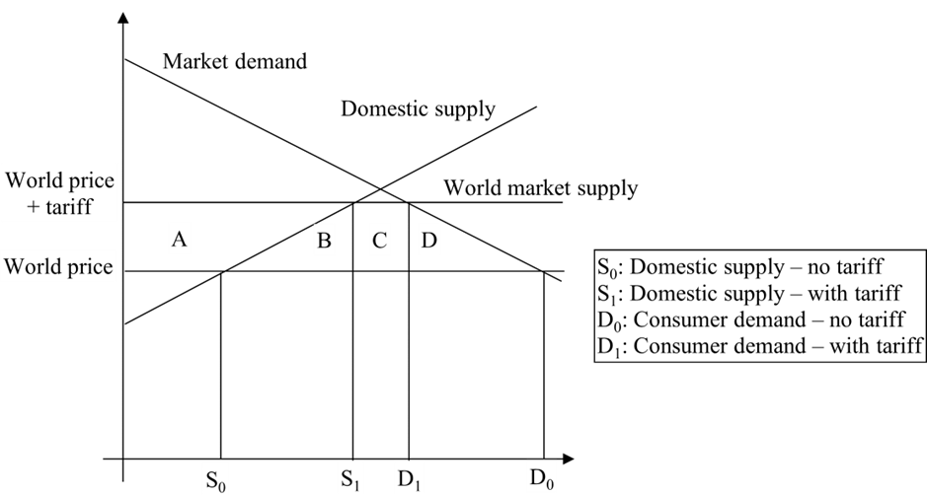

Students should explain that the analysis relates to the effects of a tariff in a small country, whose output decision has no effect on global market prices. The diagram shows supply and demand conditions in the domestic market, with competition from international producers. The world market supply curve is perfectly elastic.
Students should argue domestic producers are limited to selling the output which they can produce for less than the international price: S₀ before the tariff and S₁ after. Similarly, total market demand is determined by the world market price: D₀ before the tariff, and D₁ after.
Students should identify that there is a welfare loss to domestic consumers, A+B+C+D. A is acquired by domestic producers, B by suppliers to producers, C as tariff revenue by the government, with D the deadweight loss, indicating that society is worse off after the tariff.
I expect students to argue that within this approach, tariffs can be justified as short-term measures, especially to enable the productivity of an industry to improve, either because it is just being established, or else because it needs restructuring. Good essays may give examples and note the challenges of ensuring that tariffs do not become permanent features of policy.

(30 marks)

END OF SOLUTIONS

